|  |  |
| --- | --- |
| Internship Project Title | **RIO-125: Real Time Chat Application - Develop a MEAN Stack Application with User-Specific Features** |
| Name of the Company | TCS iON |
| Name of the Industry Mentor | Debashis Roy |
| Name of the Institute | ICT Academy of Kerala |

|  |  |  |  |  |
| --- | --- | --- | --- | --- |
| Start Date | End Date | Total Effort (hrs.) | Project Environment | Tools used |
| 25-06-2023 | 10-08-2023 | 125 | VS Code, Windows, Firefox | NodeJS with Express, MongoDB Atlas, Postman |

**TABLE OF CONTENT**

* Acknowledgements
* Objective
* Introduction / Description of Internship
* Internship Activities
* Approach / Methodology
* Assumptions
* Exceptions / Exclusions
* Charts, Table, Diagrams
* Algorithms
* Challenges & Opportunities
* Risk Vs Reward
* Reflections on the Internship
* Recommendations
* Outcome / Conclusion
* Enhancement Scope
* Link to code and executable file
* Research questions and responses

# **Acknowledgements**

I thank TCS ion and the industry mentor for their guidance and support as well as for providing necessary information regarding the project. I am immensely grateful to TCS ion for the invaluable guidance and unwavering support they have provided throughout the course of this project. Their expertise and insights have been instrumental in shaping the direction of the project and ensuring its successful execution.

# **Objective**

The objective of this project is to develop a real-time chat application using the MEAN stack (MongoDB, Express.js, Angular, and Node.js). The application will provide user-specific features and enable real-time communication between users.

# **Introduction/Description of Internship**

The internship opportunity offered by TCS iON (Tata Consultancy Services iON) provides students with a valuable learning experience in the field of software development and project management. During the internship, students will have the opportunity to work on a real-world project, gaining practical knowledge and skills that will enhance their understanding of software development processes.

This project involves the development of a Real Time Chat Application using the MEAN stack (MongoDB, Express.js, Angular, and Node.js). The project aims to create a user-friendly and efficient chat application that enables real-time communication between users. It will also incorporate user-specific features such as message search, notification settings, and chat preferences.

# **Internship Activities**

Some of the activities to be done during the internship includes following

* Orientation and Training: Participating in an orientation session and receiving training to understand the organization's culture, policies, and work processes.
* Project Planning: Collaborating with mentors to define project objectives, scope, timeline, and deliverables.
* Literature Review: Conducting research and reviewing relevant literature to gain a comprehensive understanding of the project domain.
* Requirement Analysis: Identifying and documenting the specific requirements of the project, including user needs and technical specifications.
* Design and Development: Creating prototypes, wireframes, or design concepts based on project requirements, followed by iterative development and coding.
* Testing and Quality Assurance: Performing testing procedures to ensure that the project functions as intended and meets quality standards.
* Documentation: Maintaining thorough documentation of the project's progress, design decisions, codebase, and any modifications made. Submitted daily activity reports, interim reports.

# **Approach / Methodology**

1. Initially we create a backend server to serve and process requests from the client.
2. The backend communicates with the database and retrieves / stores information.
3. For this project I have used MongoDB Atlas which is a MongoDB hosted in the cloud.
4. We model the data items to be stored in the database. This is done with the mongoose package which helps in data modeling for MongoDB.
5. The models are defined with mongoose schemas.
6. The models are made for user signup, message storing
7. Make controllers for the above models to get, post or update information regarding the models.
8. The frontend is made with Angular JS.
9. The frontend communicates with the backend by making get/post and other methods of requests to enable the various functions of inventory management
10. New users can register.
11. Logged in users can view chat history and options to send new messages.
12. When a user is logged into the chat application, having the ability to receive real-time notifications for new messages.
13. User can mute, block their friends.
14. The landing page is designed to be a dashboard that includes the friend list with status (online or offline) and their previous conversations.
15. User can add their picture as profile picture.

**Assumptions**

* The project will focus solely on the development of the real-time chat application and will not include additional features such as video calls.
* The project will cover user-specific features like notification settings, and user status, but won't delve into advanced personalization features.
* Basic security measures will be implemented, such as user authentication and authorization, to ensure user data privacy and prevent unauthorized access.
* The project timeline considers a standard development cycle and might not account for unforeseen delays or disruptions.
* Changes to project requirements are anticipated to be minimal and won't significantly impact the overall development process.

**Exceptions / Exclusions**

* Advanced security features such as end-to-end encryption, advanced intrusion detection, and deep security audits are beyond the scope of this project.
* Video/audio file sharing , group chats are not included in this project.
* While efforts will be made to ensure compatibility across modern web browsers, comprehensive testing for older or less common browsers is not part of the project scope.
* In-depth user behavior analytics and reporting features are not included in the project's scope.

# **Flow diagram**

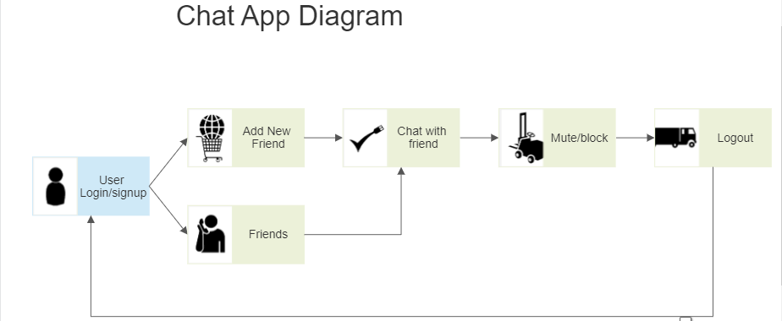

**Algorithms**

**WebSockets**: Implement WebSocket-based communication for real-time messaging. Use libraries like Socket.io to handle bi-directional communication between the server and clients.

**MongoDB Queries**: Use MongoDB to store chat messages. Implement efficient querying algorithms to retrieve messages for specific conversations, users, or time ranges.

**Token-Based Authentication**: Implement token-based authentication using JWT (JSON Web Tokens) to ensure secure user authentication and authorization for accessing chat features.

**Online/Offline Status**: Implement a real-time presence system to indicate whether users are online or offline. Use WebSocket connections to update the status in real-time.

**Challenges & Opportunities**

**Real-Time Communication**: Ensuring seamless real-time communication between users can be challenging due to factors like latency, network stability, and synchronization of messages.

**Scalability:** As the user base grows, handling a large number of concurrent users while maintaining performance and responsiveness can be a significant challenge.

**User Experience:** Designing an intuitive and responsive user interface that provides a seamless chat experience across different devices and screen sizes requires careful planning.

**Opportunities:**

**Learning and Skill Development:** The project offers interns a chance to learn and apply the MEAN stack technologies, gaining practical experience in full-stack web development.

**Innovation**: Developing a chat application provides opportunities to implement creative features, enhance user engagement, and explore new ways of communication.

**Real-World Project Experience:** Working on a real-world project allows interns to understand software development lifecycles, collaboration, and problem-solving in a professional context.

**User-Centric Design:** Designing user-friendly interfaces and optimizing the user experience fosters an understanding of user-centered design principles.

**Exposure to Industry Standards**: Following best practices in software development, security, and performance optimization offers insights into industry standards.

**Risk Vs Reward**

**Technical Challenges**: Developing a real-time chat application involves complex technical challenges, including real-time communication synchronization, scalability, and security. Failure to address these challenges could lead to performance issues, security vulnerabilities, and an unsatisfactory user experience.

**Data Security:** Inadequate security measures can result in data breaches, compromising user privacy and potentially leading to legal and reputational consequences.

**Maintenance and Updates:** After the initial development, ongoing maintenance, bug fixes, updates, and addressing user feedback will be necessary. Neglecting maintenance can lead to application instability and user dissatisfaction.

**Rewards:**

**Learning and Skill Development**: Developing a real-time chat application provides valuable hands-on experience with MEAN stack technologies, enhancing both technical and soft skills.

**Innovation**: Successfully implementing creative features, user interactions, and engagement mechanisms can lead to a unique and attractive application.

**Career Advancement**: A functional chat application in your portfolio can demonstrate your capabilities to potential employers or clients, opening doors to new career opportunities.

**Reflections on the Internship**

**Technical Skills:** Reflect on the technical skills you've acquired during the internship. This could include proficiency in using the MEAN stack technologies, implementing real-time communication, working with databases, and handling user authentication.

**Problem-Solving:** Consider the challenges you faced during the development process and how you approached and resolved them. Reflect on how these experiences have enhanced your problem-solving skills.

**Project Management:** Evaluate how effectively you managed your time, met deadlines, and prioritized tasks. Reflect on your ability to adapt to changes and unexpected challenges.

**Personal Growth:** Reflect on how the internship has contributed to your personal growth. This could include increased confidence, improved communication skills, and a deeper understanding of your strengths and areas for improvement.

**Future Applications:** Consider how the skills and knowledge gained during the internship can be applied in your future academic, professional, or personal endeavors.

**Recommendations**

**Clear Project Objectives:** Clearly define the project objectives, scope, and expected outcomes with your intern. This helps set the right direction and aligns the intern's efforts with the project's goals.

**Structured Learning Plan:** Develop a structured learning plan for the intern, outlining the technologies, tools, and concepts they will need to grasp during the internship. This plan ensures a gradual and organized learning curve.

**Regular Check-Ins**: Schedule regular check-in meetings to discuss the intern's progress, challenges, and questions. These meetings provide opportunities to provide guidance, clarify doubts, and offer constructive feedback.

**Outcome / Conclusion**

In conclusion, the real-time chat app internship has been a transformative journey filled with learning, growth, and accomplishment. The project's successful completion reflects the dedication, hard work, and collaborative efforts put forth during this internship. This internship has extended beyond technical aspects, emphasizing the importance of timely work, effective communication, and adaptability. The insights gained from working alongside mentors and colleagues will undoubtedly shape future endeavors in the field

With gratitude for the opportunity to contribute to this impactful project, I look forward to further exploring the dynamic world of software development and embracing new challenges with enthusiasm and confidence.

The outcome of the real-time chat app internship is a fully functional chat application developed using the MEAN stack (MongoDB, Express.js, Angular, Node.js). This application enables real-time communication between users, incorporates user authentication, and user-friendly interface design. The internship provided a hands-on opportunity to apply MEAN stack technologies and gain practical experience in full-stack web development, real-time communication, and user-centered design principles. The successful completion of the project highlights the intern's technical skills, problem-solving abilities, and growth in the software development field.

**Screenshots**

**Home Page**



**Login Page**

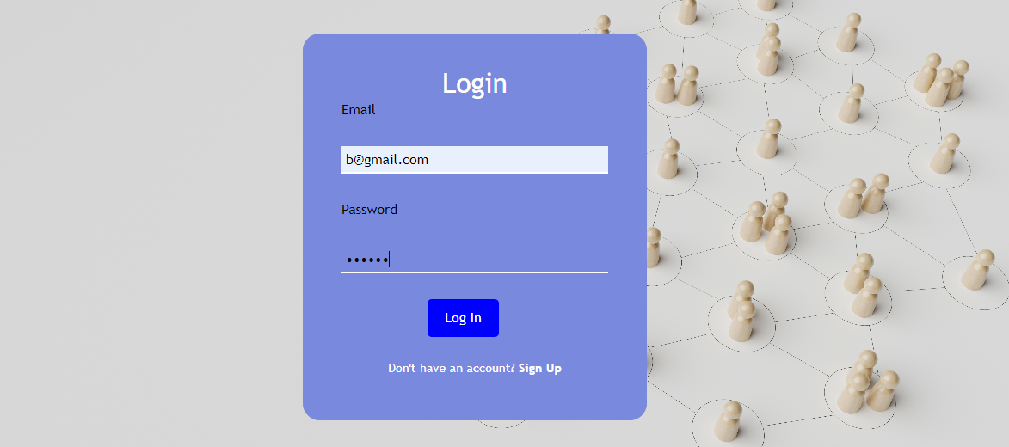

**Dashboard**

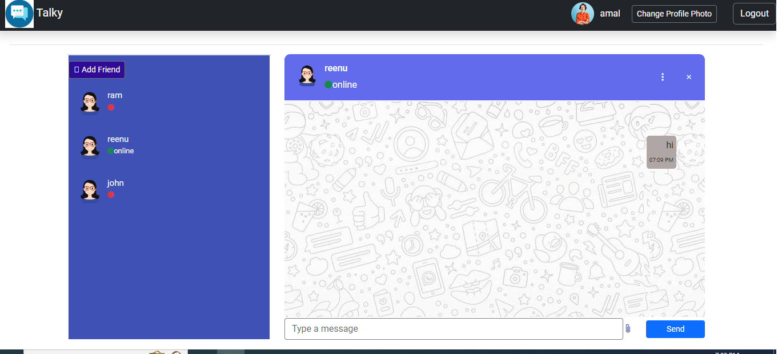

**Enhancement Scope**

**File Sharing:** Integrate a file-sharing feature that allows users to exchange files within the chat application. Implement secure file uploads and downloads, and ensure compatibility with different file formats.

**Multi-User Chatrooms:** Extend the application to support group chat functionality. Users can create or join chatrooms, facilitating communication among multiple participants simultaneously.

**Video and Voice Calling:** Enhance the user experience by adding video and voice calling capabilities to the chat application.

**Message Reactions and Emojis:** Implement message reactions and emoji support to add an element of fun and expressiveness to the chat interactions.

**Link to code and executable file**

**Link to code**

GitHub repository with documents submitted till now and also the code for the project:

**Reports**

[**https://github.com/amalashraf04/Tcsion-remote-internship_final_data/**](https://github.com/amalashraf04/Tcsion-remote-internship_final_data/)

**Codes**

[**https://github.com/amalashraf04/tcs_internship_codes**](https://github.com/amalashraf04/tcs_internship_codes)

**Link to project video**

[**https://www.loom.com/share/dc9c5c9510c349b8bf040c668df21216?sid=75a5089d-0678-4360-b533-8dcaca81dc17**](https://www.loom.com/share/dc9c5c9510c349b8bf040c668df21216?sid=75a5089d-0678-4360-b533-8dcaca81dc17)

**Research questions and responses**

What impact does real-time communication have on user engagement and interaction within a chat application?

Response: Real-time communication enhances user engagement and interaction within a chat application by providing instant feedback, fostering dynamic conversations, and enabling users to engage in meaningful discussions. This feature creates a more interactive and immersive experience, making the application more attractive to users.